Obstacle detector

Circuit diagram:

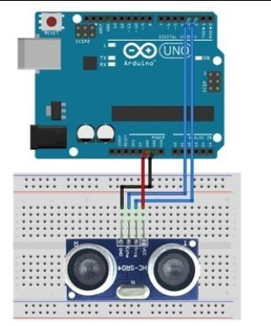

Theory:

CONCEPT USED:

➢ By using Ultrasonic sensor

➢ By using distance measurement formulae

LEARNING AND OBSERVATIONS:

• Connections in Breadboard and wiring.

• How to control Ultrasonic sensor and its coding.

• Use of Ultrasonic sensor for obstacle detection

OBSERVATION:

➢ visible shown data of ultrasonic waves

➢ data displayed on serial moniter

PROBLEMS & TROUBLESHOOTING:

o To select the right port and type of arduino

o To check the loose connections

o To check the connections according to the codes

PRECAUTIONS:

o Handle Ultrasonic sensor carefully

o Do not connect sensor while arduino is already powered up.

o Do not connect arduino till the circuit is complete

OUTCOMES:

o distance showing in serial monitor as obstacle distance.

o It can be used as for detection of object far away.